Supplementary Materials:
Dark Topological Valley Hall Edge Solitons
Boquan Ren¹, Hongguang Wang¹, Victor O. Kompanets², Yaroslav V. Kartashov², Yongdong Li¹, and Yiqi Zhang^{1,*}
¹Key Laboratory for Physical Electronics and Devices of the Ministry of Education & Shaanxi Key Lab of Information Photonic Technique, School of Electronic Science and Engineering, Xi’an Jiaotong University, Xi’an 710049, China
²Institute of Spectroscopy, Russian Academy of Sciences, Troitsk, Moscow, 108840, Russia
*Corresponding authors: zhangyiqi@xjtu.edu.cn

Topological protection of the dark valley Hall edge soliton
The composite honeycomb lattice with a closed triangular domain wall created in it is displayed in Fig. S1. One can see that the domain wall is slightly darker than surrounding lattice regions. To depict the domain wall more clearly, we magnify its three corners (as indicated by three red boxes with numbers 1, 2 and 3) in the bottom three panels in Fig. S1. The structure of the domain wall around corners is highlighted by the red ellipses.
To obtain dynamics shown in Fig. 4 of the main text, we launched a pair of dark valley Hall edge solitons nested in common edge state at $k_{y}=-0.3K$ on the edge connecting corners 2 and 3 of the domain wall. As shown in Fig. 4 in the main text, this pair of dark valley Hall edge solitons will propagate along the domain wall in the counter-clockwise direction at a constant velocity and circumvent the corners of this structure without radiating energy into the bulk.

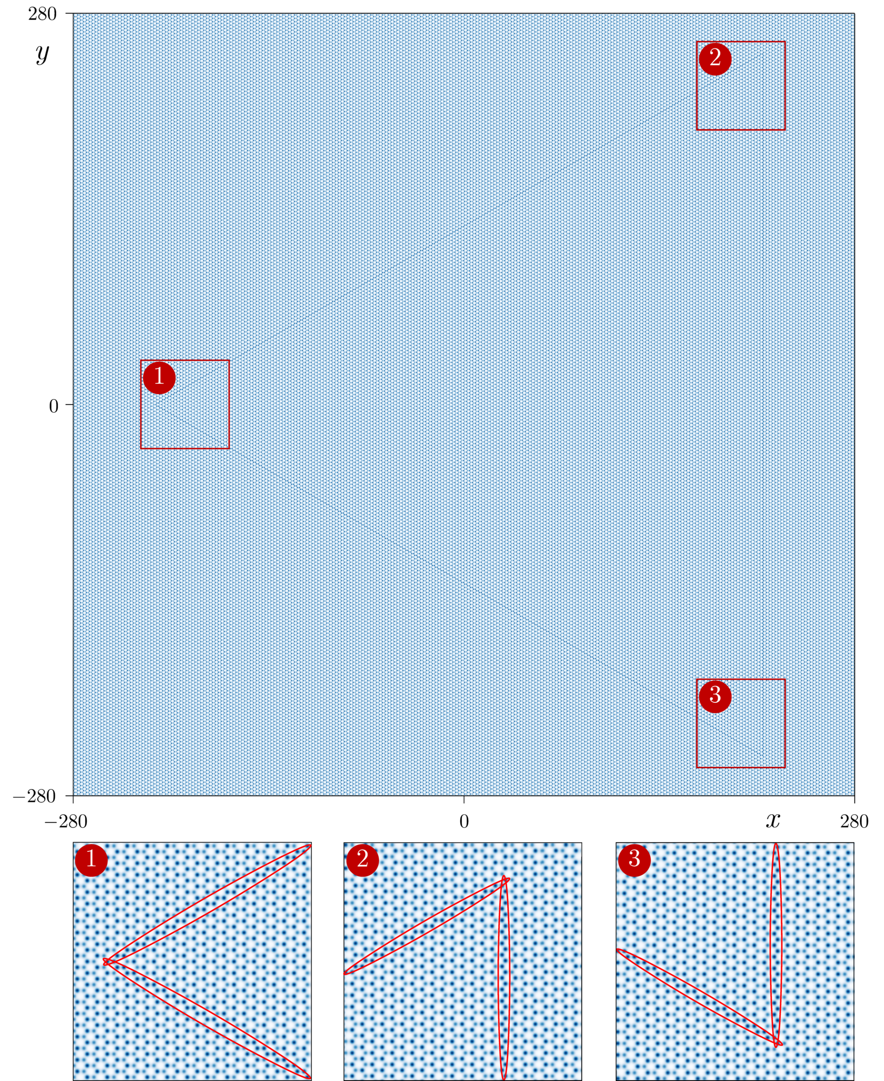
Fig. S1. Triangular domain wall created in the composite honeycomb lattice. Three corners of this domain wall are magnified in the bottom panels. In these panels, the position of the domain wall is indicated by the red ellipses.

